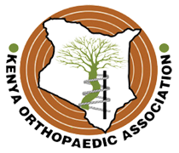

INTERNATIONAL SCHOLARS PROGRAM 2019

**Attention!!Attention!! Attention!!**

Each year, the AAOS International Scholars Program accepts applications from eligible countries, Kenya being one of them. Awardees attend a surgical skills course of their choice at the OLC Education & Conference Center and spend five days in an observership at a major US hospital of medical institution. The scholarship award covers the OLC course registration fee, hotel accommodations, and most of the air travel expenses

**22 July 2018** - deadline for submitting applications for the 2019 AAOS International Scholars Program

Applications are reviewed and evaluated by the AAOS International Committee on the following criteria:

* Leadership roles or positions
* Proven record of teaching either academically or within your professional organizations and/or health care community
* Commitment to improving patient care
* History of volunteering in your community and country

Visit [www.aaos.org/international/scholar](http://www.aaos.org/international/scholar) for more information such as eligibility criteria, application process and any other question you may have.

If you require any assistance, kindly contact the Chairman KOA on [jameskigera@yahoo.co.uk](mailto:jameskigera@yahoo.co.uk)